Z-Z-Z
We are learning about the Letter Z and the /z/ sound this week! The Z sound is the “buzzing bee” sound and a skinny air sound! To make our /z/ sound we keep our tongue “in jail” (behind our teeth), our lips are smiling, and a “skinny” stream of air is pushed out. Don’t forget, this is a noisy sound! Our motors are on for the /z/ sound! Put your hand on your throat and feel the vibrations!

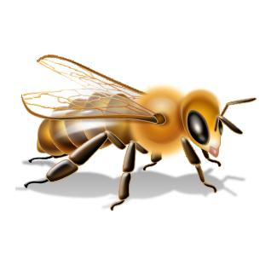
The Buzzing Bee Sound
Activities you can practice at home:
*Make Zippity-Doo Glitter Bags: Place glitter in a zip-lock bag, have your child brush glue over objects (such as pine cones, or paper shapes) and then drop them into the glitter. Remove objects and set on a peper towel to dry.
* Visit the Zoo and look for the zebras!
* Eat some /z/ foods: zucchini, zucchini bread, zebra cakes
* Go on a treasure hunt and find things around the house that start with the /z/ sound!

*Make a zip-lock bag. Glue pictures on the front and back of a piece of paper that fits into your bag. Do a number of these pictures around a certain subject, such as zoo animals, Then staple all the bags together leaving the zipper side of the bags on the outer edge.

Some of the pictures in our treasure chest this week are:
Zipper, Zebra, Zig Zag, Zucchini, Zoo, Zero

Practice these words, and talk about the /z/ sound every day with your child!
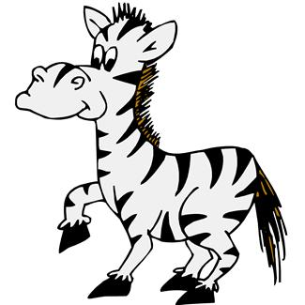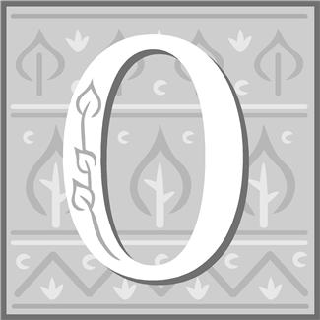

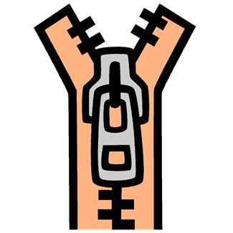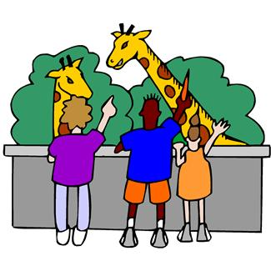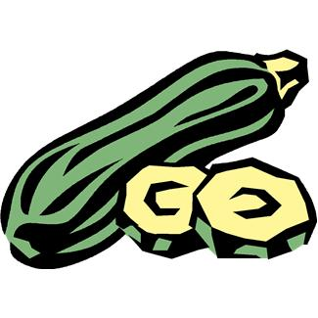

Books to read aloud:
- Zella, Zack and Zodiak by Bill Peet
- If Anything Ever Goes Wrong at the Zoo by Mary Jean Hendrick
- If I Ran the Zoo by Dr. Seuss
- Put Me in the Zoo by Robert Lopshire
- The Zebra-Striped Whale with the Polka-Dot Tail by Shari F. Donahue
- Zoom! Zoom! Zoom! I'm Off to the Moon by Dan Yaccarino

