V-V-V
We are learning about the Letter V and the /v/ sound this week! The V sound is the “vacuum cleaner” sound and a Lip Cooler sound! To make our /v/ sound we place the top teeth on the bottom lip and blow air out. Be sure to turn your motor on like a vacuum cleaner! The /v/ sound is called the vacuum cleaner sound because when you make the /v/ sound you are forcing air out of your mouth and turning your “motor”/voice on to sound like a vacuum. It also is one of our lip coolers, because the cool air we blow out cools our lips!

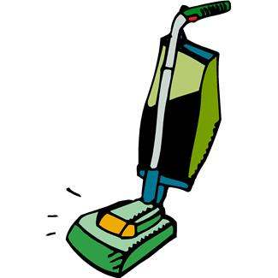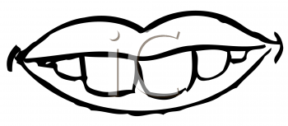

Vacuum Sound

Activities you can practice at home:
*Make a sun visor and decorate it with fun stickers! Or, make a vest out of a paper bag and decorate your new super hero vest!
* Learn about volcanoes and make a volcano! http://chemistry.about.com/cs/howtos/ht/buildavolcano.htm
* Make a salad with a variety of vegetables!
* Go on a vegetable treasure hunt at the grocery store, or make a Vegetable poster by finding pictures of vegetables in magazines and gluing them on a poster!
* Go on a treasure hunt and find things around the house that start with the /v/ sound!

Some of the pictures in our treasure chest this week are:
Vacuum, Van, Valentine, Vest, Volcano, Vase
Practice these words, and talk about the /d/ sound every day with your child!

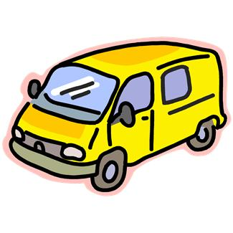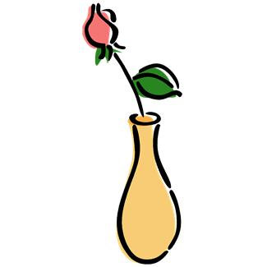
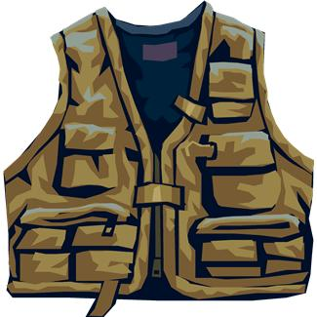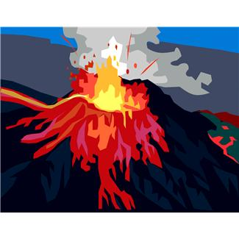

Books to read aloud:
- Silly Tilly's Valentine by Lillian Hoban
- Valentine Mice! by Bethany Roberts
- The Valentine Bears by Eve Bunting
- The Velveteen Rabbit by Margery Williams Bianco
- The Ugly Vegetables by Grace Lin
- June 29, 1999 by David Wiesner
- Volcanoes: Mountains
- That Blow Their Tops by Nicholas Nirgiotis
- VeggieTales Books

