S-S-S
We are learning about the Letter S and the /s/ sound this week! The S sound is the “hissing snake” sound and a skinny air sound! To make our /s/ sound we keep our tongue “in jail” (behind our teeth), our lips are smiling, and a “skinny” stream of air is pushed out . The /s/ sound is called the Hissing Snake sound because when you make the /s/ sound, it sounds like you are an angry snake! Don’t forget, this is a quiet sound! Our motors are not on for the /s/ sound!

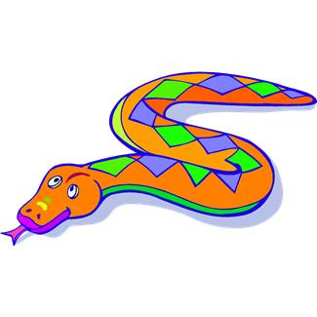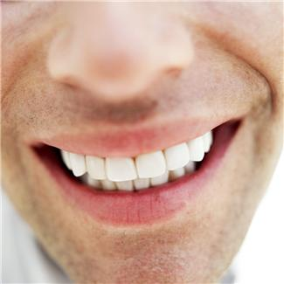
The Hissing Snake Sound
Activities you can practice at home:
*Make your own Sand Art picture online at http://www.angelwinks.net/sandart.html
* If its snowing outside you can make a snowman! If its nice outside you could play soccer!
* Eat some delicious /s/ foods: spaghetti with sauce, strawberries, soup, salad, sandwiches, salami. Can you make the letter “S” out of cooked spaghetti?
* Go on a treasure hunt and find things around the house that start with the /s/ sound!

*Makr your own soap! Here is a link on this fun activity you can do as a family—and maybe some gifts for Valentines Day!
http://crafts.kaboose.com/easysoap.html

Some of the pictures in our treasure chest this week are:
Sunglasses, Scissors, Santa, Sandwich, Sailboat, Seashell

Practice these words, and talk about the /s/ sound every day with your child!

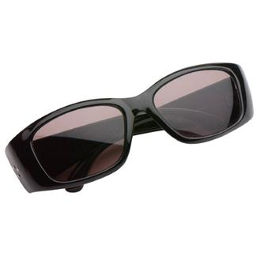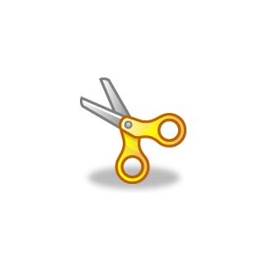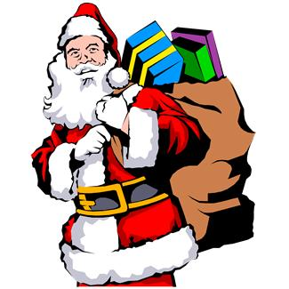
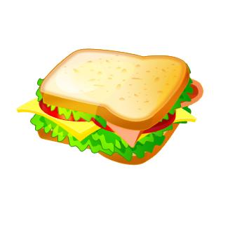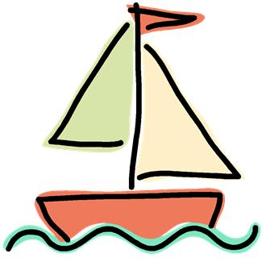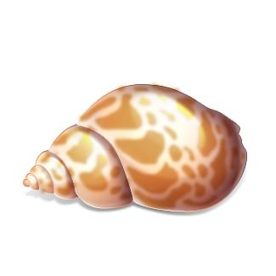

Books to read aloud:
- Snowy Day by Ezra Jack Keats
- Sand Castle by Brenda Shannon Yea
- The Seashore Book by Charlotte Zolotow
- Snow by Roy McKie & P.D. Eastman

