R-R-R
We are learning about the Letter R and the /r/ sound this week! The R sound is the “rooster” sound and a lifter! To make our /r/ sound we push our lips out a little and our tongue goes up and back! Don’t forget, this is a noisy sound! Our motors are on for the /r/ sound! Put your hand on your throat and feel the vibrations!

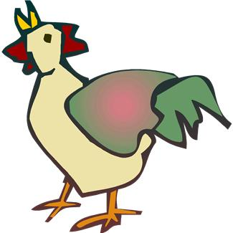

The Rooster Sound
Activities you can practice at home:
* Cut out a big /R/ out of paper and decorate it with ribbons, rick rack, and/or rope!
* Have a race with toy racecars!
* Eat some /r/ foods: radishes, raisins, rice cakes, rice, raspberries
* Go on a treasure hunt and find things around the house that start with the /r/ sound!
* Joke: What is a pirates favorite letter? Answer: “ARRRRRR”

*RAINBOW PAINTINGS
Give your child a piece of paper, some watercolors and a small brush, plus a small glass of water. Show your child how to dip her brush in the water and then spin it around on top of one of the colors. Then paint an arc on his/her paper. Encourage your child to repeat this process with other colors below or above the one already on his/her paper. Don’t forget to show him/her how to clean her brush between colors.

Some of the pictures in our treasure chest this week are:
Rabbit, Robot, Rainbow, Ring, Radio, Rat

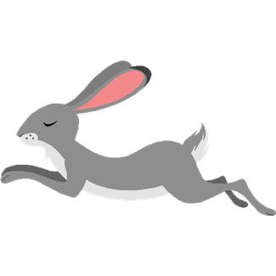
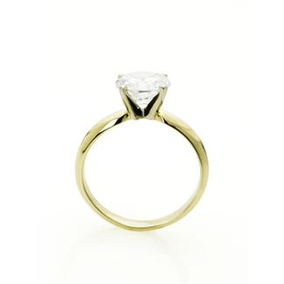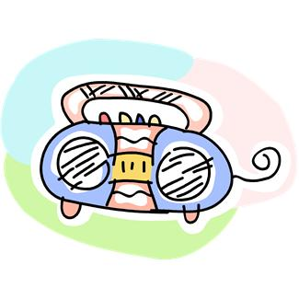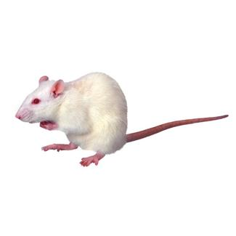

Practice these words, and talk about the /r/ sound every day with your child!

Books to read aloud:
- Rain by Robert Kalan
- Round Robin by Jack Kent
- The Velveteen Rabbit by Margery Williams Bianco
- Little Red Riding Hood retold by Harriet Ziefert
- Little Red Riding Hood: A Newfangled Prairie Tale by Lisa Campbell
- Ernst The Rainbow Fish by Marcus Pfister

