P-P-P
We are learning about the Letter P and the /p/ sound this week! The P sound is the “popping popcorn” sound and a lip popper sound! To make our /p/ sound we seal our lips together and then ‘pop’ them open with a little burst of air. The /p/ sound is called the popping popcorn sound because when you make the /p/ sound you are popping air out of your mouth just like the sound of when the popcorn is popping in the microwave. We don’t turn our “motors” (voices) on for this sound, so the /p/ is a quiet sound. We will meet his “noisy” brother next week!

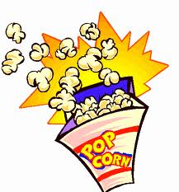

Popcorn Sound

Activities you can practice at home:
*Make pancakes for breakfast (or dinner!) and flip them in a pan!
* Pop some popcorn in the microwave. Listen to the sound and then imitate the sound with your mouth, /p,p,p,p/
*Cut out a large letter P and glue on pasta.
* For snacks you can eat: peanuts, popcorn, peanut butter, pasta, pickles, pastries…the list goes on !
* Go on a treasure hunt and find things around the house that start with the /p/ sound!

Some of the pictures in our treasure chest this week are:
Peanut, Pan, Pickle, Pig, Pizza, Pumpkin.
Practice these words, and talk about the /p/ sound every day with your child!

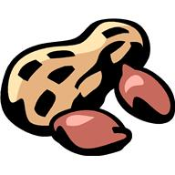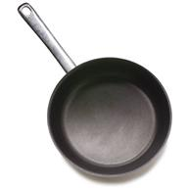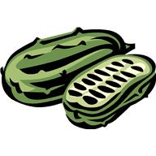

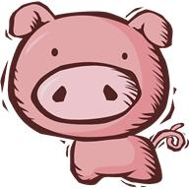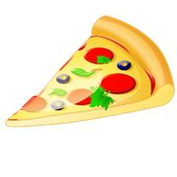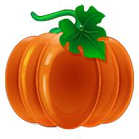

Books to read aloud:
- Hop on Pop by Dr. Seuss
- The Poky Little Puppy by Janette Sebring Lowrey
- The Teddy Bear's Picnic by Jimmy Kennedy
- Barney Says, "Please and Thank You" by Stephen White
- Pumpkin Soup by Helen Cooper
- Curious George at the Parade by Margret and H.A. Rey
- Blaze and the Grey Spotted Pony by C.W. Anderson

