N-N-N
We are learning about the Letter N and the /n/ sound this week! The N sound is the “engine” sound and a nosy sound! We are pretending to drive cars and make the /nnnnn/ sound, and feeling our noses vibrate because the nose is where the /n/ sound comes from!

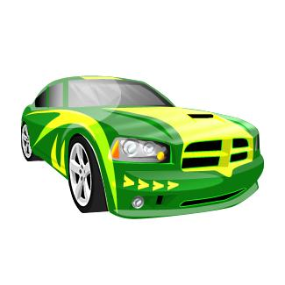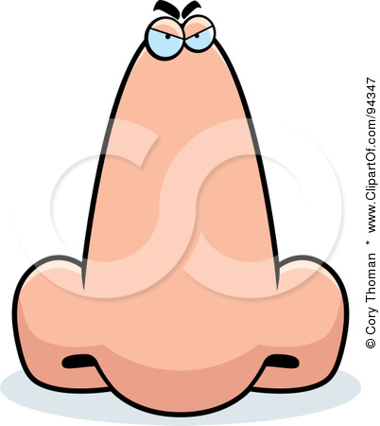
The Engine Sound

Activities you can practice at home:
*make noodles for dinner
*drive toy cars around and make “nnnn” sound
*put frosting/PB/Cream cheese/chapstick on roof of mouth to stick tip of tongue to roof for /n/
*Have a snack of nuts, nachos and nutella sandwiches!
* Make a noodle sculpture or noodle necklaces
* Go on a treasure hunt and find things around the house that start with the /n/ sound!

Some of the pictures in our treasure chest this week are:
Notebook, necklace, nest, net, newspaper, nose
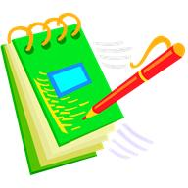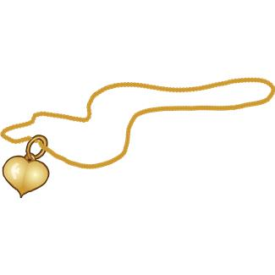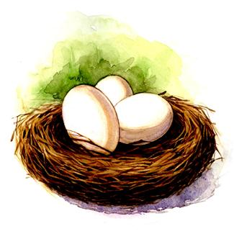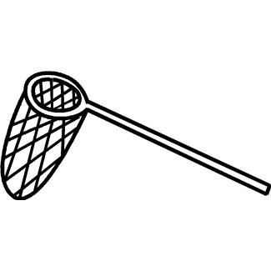

Books to read aloud:
The Best Nest by P.D. Eastman
What Newt Could Do for Turtle by Johnathan London
The Napping House by Audrey and Don Wood
Too Much Noise by Ann McGovern

