Some of the words in our treasure box this week are: moose, magnifying glass, magnet, milk, mug, and mop. Practice these words and talk about the /m/ sound everyday.

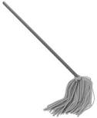

Books To Read Aloud:

- The Mitten by Jan Brett
- If You Give a Mouse a Cookie by Laura Joffe Numeroff
- Milk and Cookies by Frank Asch
- And if the Moon Could Talk by Kate Banks
- Marshmallow by Clare T. Newberry
- Are You My Mother? by P.D. Eastman

*JMG’12
M-M-M
We are learning about the Letter M and the /m/ sound this week! The M sound is the “blender” sound. We are pretending to push the button on a blender and make the /m/ sound while pretending to make milkshakes! The /m/ sound is also one of our nosey sounds because our voice “motors” are turned on but the sound comes out of our nose! Ask us about a funny trick we learned (plugging our noses) to demonstrate this!

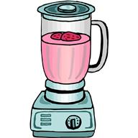
The Blender Sound

Activities you can practice at home:
*make snacks with m&m’s and marshmallows,
*make milkshakes in the blender
*put frosting/PB/Cream cheese/chapstick on lips and practice sticking lips together.
*make Macaroni and Cheese and say “mmm mmmm good” when eating the “Macaroni”
*Hum a song
* Go on a treasure hunt and find things around the house that start with the /m/ sound!

