K-K-K
We are learning about the Letter K and the /k/ sound this week! The K sound is the “stomping dinosaur” sound and a Scraper sound! To make our /k/ sound we elevate the back of our tongue and “scrape” it on the roof of our mouth, keeping our tongue tip down. The /k/ sound is called the Stomping Dinosaur sound because when you make the /k/ sound, it sounds like huge dinosaurs stomping and cracking the earth! Don’t forget to pretend your hands are stomping feet!

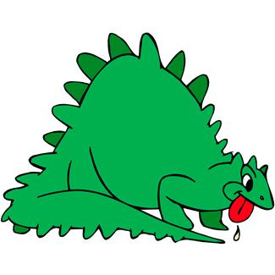
Stomping Dinosaur Sound
Activities you can practice at home:
*If you have trouble pronouncing the /k/ you can lie on your back or hang upside down—this will help your tongue naturally fall into the correct position to produce the /k/ sound.
* Look up and learn about Different Animals that start with /k/ such as: Kangaroos, Kittens, Koala Bears, and Kookaburras!
* Talk about how sometimes the letter C “borrows” the sound from the letter K, and words that start with “C” might sound like /K/! (i.e. Cookie, Cake, Candy)
* How many Keys do you have in your house? How many doors are there you can unlock with keys?
* Go on a treasure hunt and find things around the house that start with the /k/ sound!

*Make a kite out of paper, decorate it, and try to fly it!

Some of the pictures in our treasure chest this week are:
Kangaroo, Koala, Kettle, Key, Kazoo, Kite
Practice these words, and talk about the /k/ sound every day with your child!

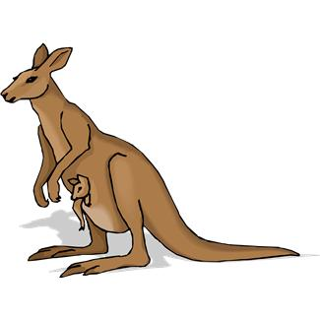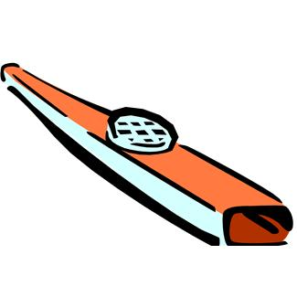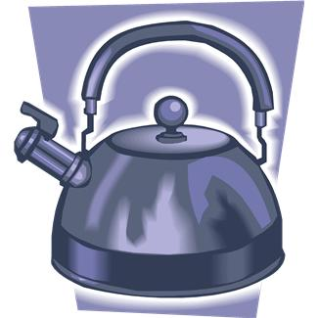
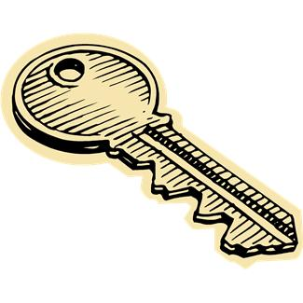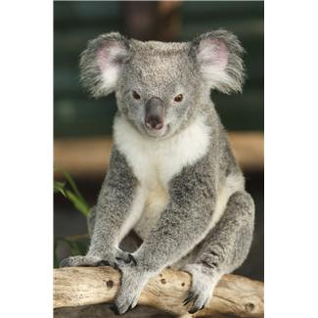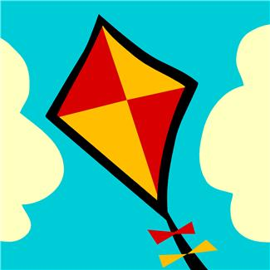

Books to read aloud:
- The Korean Cinderella by Shirley Climo
- The Emperor and the Kite by Jane Yolen
- Does a Kangaroo Have a Mother, Too? by Eric Carle
- Clifford's Kitten by Norman Bridwell
- A Kiss for Little Bear by Else Holmelund Minarik
- The Kitten Book by Jan Pfloog
- The King, the Mice and the Cheese by Nancy & Eric Gurney
- The Frog Who Would Be King by Kate Walker

