H-H-H
We are learning about the Letter H and the /h/ sound this week! The H sound is the “panting” sound and a windy sound! We are practicing our “panting” like a hot dog and putting our hands in front of our mouth to feel the air come out! Is the air that comes out hot or cold? Try it out and see!

The Panting Sound

Activities you can practice at home:
*make haystacks out of melted chocolate chips and chow mein noodles!
*Practice the /h/ sound on a mirror and see what happens!
*grill up some hot dogs and hamburgers!
*Trace your hand on paper and turn it into a funny creature!
* Go on a treasure hunt and find things around the house that start with the /h/ sound!

Some of the pictures in our treasure chest this week are:
Heart, Horn, Hanger, Hat, Helmet, Horse, House..
Practice these words and talk about the /h/ sound every day with your child!

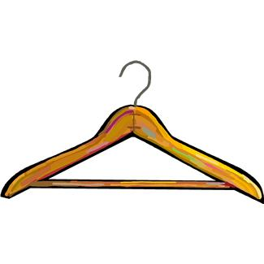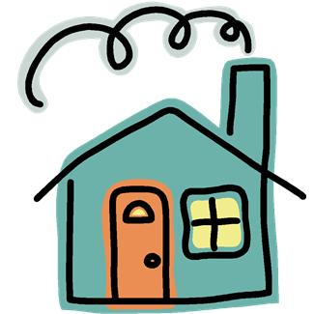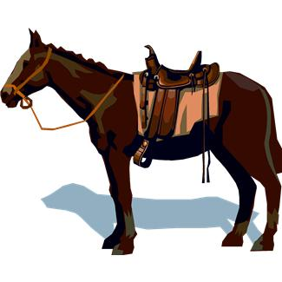

Books to read aloud:
My “H” Sound Box by Jane Belk Moncure
- Old Hat New Hat by Stan and Jan Berenstain
- The Big Honey Huntby Stanley and Janice Berenstain
- Hector's Hiccups by Lee Wardlaw
- My Hands by Aliki
- The Happy Hedgehog Band by Jill Barton
- Ho for a Hat! by William Jay Smith

