G-G-G
We are learning about the Letter G and the /g/ sound this week! The G sound is the “drinking” sound and a Scraper sound! To make our /g/ sound we elevate the back of our tongue and “scrape” it on the roof of our mouth, keeping our tongue tip down. But, we also have to turn our motors on this time, because it is the noisy brother! The /g/ sound is called the Drinking sound because when you make the /g/ sound, it sounds like you are drinking a glass of water!

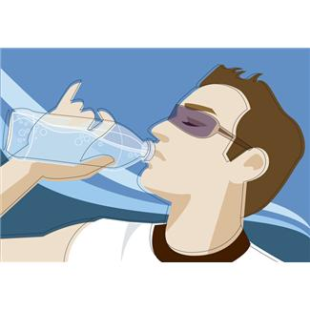
The Drinking Sound
Activities you can practice at home:
*If you have trouble pronouncing the /g/ you can lie on your back or hang upside down—this will help your tongue naturally fall into the correct position to produce the /g/ sound.
* Drink a variety of different drinks and see if you can make the /g/ sound while swallowing!
* Have some snacks that start with /g/: garden salad, granola bars, graham crackers, grapefruit, green beans, grape juice
* Go on a treasure hunt and find things around the house that start with the /g/ sound!

*Make a funny grass-haired man: You will need a styrofoam cup, dirt, grass seeds, water, felt markers. Color a face on the cup. Fill the cup 3/4 full of dirt. Place grass seeds on top. Add a little more dirt. Water the seeds. Watch for your man to grow hair of grass!!

Some of the pictures in our treasure chest this week are:
Guitar, Gift, Gorilla, Ghost, Game, Gum

Practice these words, and talk about the /k/ sound every day with your child!

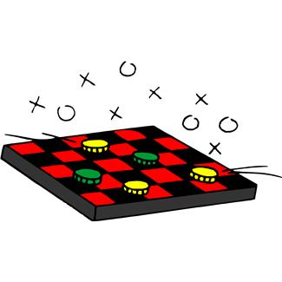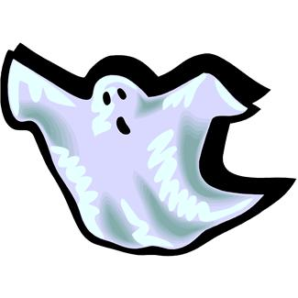
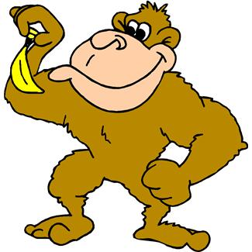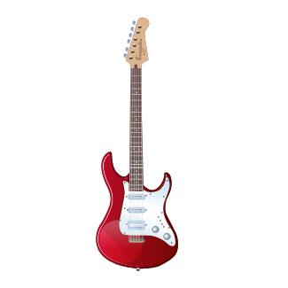

Books to read aloud:
- Giving by Shirley Hughes
- Good Night by Claire Masurel & Marie H. Henry
- The Golden Goose retold by Uri Shulevitz
- The Three Billy Goats Gruff by Paul Galdone
- Goodnight Moon by Margaret Wise Brown

