F-F-F
We are learning about the Letter F and the /f/ sound this week! The F sound is the “sprinkler” sound and a Lip Cooler sound! To make our /f/ sound we place the top teeth on the bottom lip and blow air out. The /f/ sound is called the sprinkler sound because when you make the /f/ sound you are forcing air out of your mouth like a sprinkler. When the water comes out of the hose, it sounds like /f-f-f-f-f/. It also is one of our lip coolers, because the cool air we blow out cools our lips!

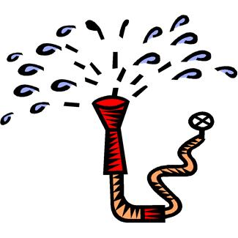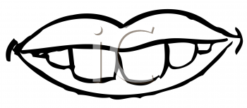

Sprinkler Sound

Activities you can practice at home:
*Make a paper fan - color a design on a piece of blank paper and fold accordion style.
* Design a family flag or a flag showing many different things starting with the letter F.
*Cut out a large letter F and glue on goldfish.
* For snacks you can eat: fish sticks, fruit salad, French fries, French toast, fruitcake, gold “fish”
* Go on a treasure hunt and find things around the house that start with the /f/ sound!

Some of the pictures in our treasure chest this week are:
Fish, Feathers, Fan, Frog, Fence, Flower
Practice these words, and talk about the /d/ sound every day with your child!

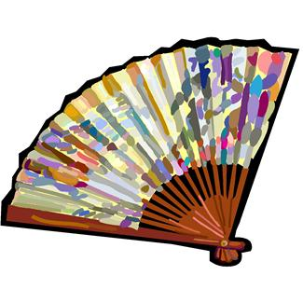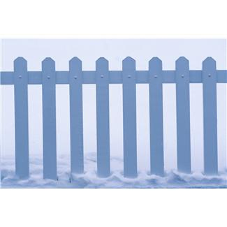
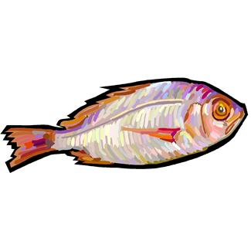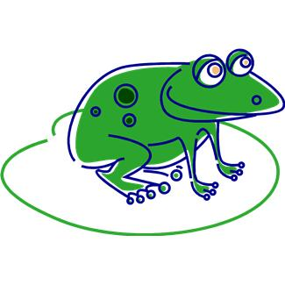

Books to read aloud:
- The Rainbow Fish by Marcus Pfister
- Forest by Laura Godwin
- Feathers Like a Rainbow by Flora
- The Foot Book by Dr. Seuss
- Down on the Funny Farm by P.E. King
- The Firebird retold by Selina Hastings (or the version by Demi)
- The Biggest Fish by Sheila Keenan
- Fritzi Fox Flew in From Florida by Leah Komaiko

