D-D-D
We are learning about the Letter D and the /d/ sound this week! The T sound is the “raindrop” sound and another Tip-Tapper sound! To make our /d/ sound we put the tip of our tongue on our alveolar ridge (the bump behind our top front teeth) and push and release! This is T’s noisy brother! He is made just like the /t/ sound but we turn our “motors” on!

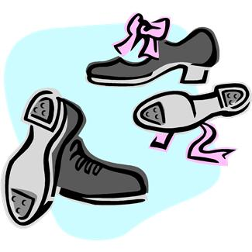

Raindrop Sound

Activities you can practice at home:

*Digging for Delightful D's
In a sandbox, or tub filled with packing material, bury many paper d's and D objects. Let the children dig for d's, and as each letter is found, have the children glue it to paper to make a collage of Delightful D-designs.
"Where Has My Little Dog Gone?" Game
On a felt, magnetic or poster board, attach 10 picture cards of "D" items. Behind 2 or 3 of the pictures, hide a construction paper dog. Sing "Oh Where Oh Where Has My Little Dog Gone?". After singing, ask a child to guess where the little dog is by naming the item in a "D" picture. Sing the song again, until all the little dogs have been found.
*Go on a treasure hunt around your house and see how many /d/ things you can find!
*Cut out a large letter D and "dot" with bingo dabbers or stick on colored "dots".
Coffee Can Drum

* Practice holding a goldfish or m&m with the tip of your tongue on the bump behind your teeth and see how long you can hold it!
*Practice the /d/ sound in a mirror and see what happens!
* Practice a fun DANCE!
* Brush teeth and tongue with toothpaste on a toothbrush!
* Go on a treasure hunt and find things around the house that start with the /d/ sound!

Some of the pictures in our treasure chest this week are:
Dinosaur, Dog, Dolphin, Donuts, Door, and Drum.
Practice these words, and talk about the /d/ sound every day with your child!

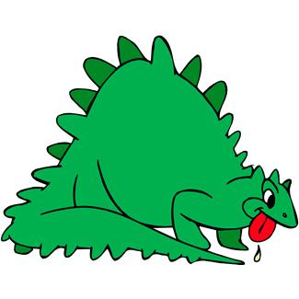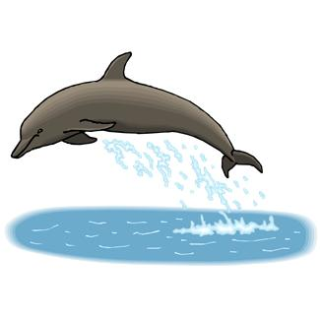
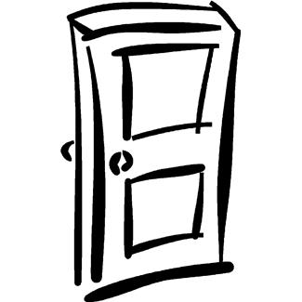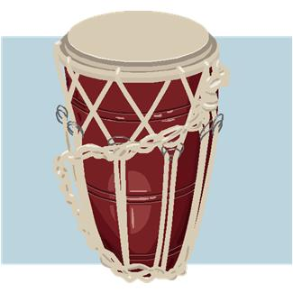

Books to read aloud:
- One Duck Stuck by Phyllis Root
- Ducks Disappearing by Phyllis Reynolds Naylor
- Go, Dog. Go! by P.D. Eastman
- Duncan the Dancing Duck by Syd Hoff
- Danny and the Dinosaur by Syd Hoff

