B-B-B
We are learning about the Letter B and the /b/ sound this week! The B sound is the “bouncing ball” sound and a lip popper sound! To make our /b/ sound we seal our lips together and then ‘pop’ them open with a little burst of air. It often helps some children produce the sound if paired with a visual/motor cue. For the bouncing ball sound we move our hand as if we are dribbling a basketball while producing /b, b, b/. We turn our “motors” (voices) on for this sound, which means that /B/ is our noisy brother of /p/!

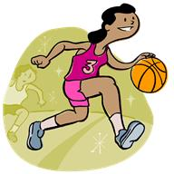

Bouncing Ball Sound

Activities you can practice at home:
* Make Burritos for dinner! Don’t forget the Beans! How about Bacon and bagels for Breakfast? For snacks you can eat: bananas, bologna, buttered noodles, berries, broccoli!
* Practice dribbling/bouncing a ball and say the /b/ sound each time it hits the floor! Make and play with bubbles!
* Cut out a large letter B and glue on “beautiful” things, or maybe paint it black and blue with a brush so it looks like it has bruises! Or, find pictures and stickers of balls and butterflies and bats!
* Buy a Bandana from the craft store and decorate it!
* Go on a treasure hunt and find things around the house that start with the /b/ sound!

Some of the pictures in our treasure chest this week are:
Ball, Boat, Baseball Bat, Bear, Bell, Bee
Practice these words, and talk about the /b/ sound every day with your child!

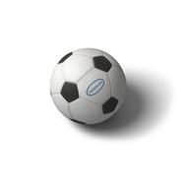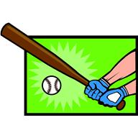
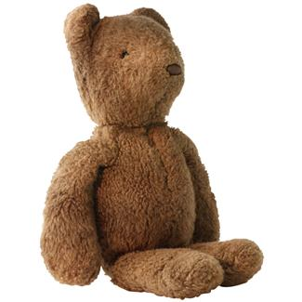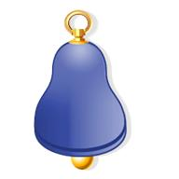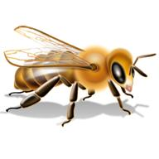

Books to read aloud:
- The Berenstains' B Book
- B is for Books! by Annie Cobb
- The Big Balloon Race by Eleanor Coerr
- The Little Ballerina by Katharine Ross
- The Lamb and the Butterfly by Arnold Sundgaard
- Berlioz the Bear by Jan Brett
- Blueberries for Sal by Robert McCloskey
- Cowgirl Rosie and Her Five Baby Bison by Stephen Gulbis
- The Baby Beebee Bird by Diane Redfield Massie

